GHA STATEMENT OF SERVICES

This Statement of Services summarises the terms of the Agreement signed on the 28 February 2021 between GHA Loyalty DMCC (“GHA”) and Minor Hotels Europe & Americas, S.A. (“Member”) [a Spanish company that is indirectly 95,865% owned by Minor International PCL (“Minor Hotels”)] (jointly “Minor Group”), that applies to all Participating Hotels in respect of the outsourced loyalty services being provided by GHA to all of Minor Hotels’ branded hotels (the “GHA Agreements). By signing this Statement of Services in respect of [name of specific managed or franchised hotel], [name of legal entity operating or owning the hotel which is the counterparty in the management or franchise agreement] (the “Hotel”) adheres to the GHA Agreements (and the modifications that may be agreed between Member and GHA), and agrees to pay GHA the amount for the services according to the GHA Agreements and summarized below. This Statement of Services is a summary document which does not replace the GHA Agreements; in case of a discrepancy the terms of the GHA Agreements shall prevail.

- LOYALTY PROGRAMME

  - The loyalty commissions will be invoiced monthly to the Hotel as follows:

Type of Stay | Applicable Loyalty Commission (“Fees”) for revenues on folio
Enrolment Stay: | USD 0.00
”Same Hotel”, “Intra-Brand” or “Intra-Group” Stay  Stay at the Hotel of a Participant who was enrolled into the loyalty programme by any hotel that is part of Minor Group | 2.0% of Qualified Rooms Revenue generated during the relevant stay.  Plus  1.5% of Qualified Non-Rooms Revenue generated during the stay
Cross-Brand Stay:  All other stays at the Hotel of a Participant (for example stays by Participants who enrolled into the loyalty programme directly with GHA or with another member brand in the Global Hotel Alliance that is not part of Minor Group). | 10.0% of Qualified Rooms Revenue generated during the relevant stay (reduced to 5% where the Programme Participant has made two previous stays in any of Minor Group’s participating hotels)  Plus  1.5% of Qualified Non-Rooms Revenue generated during the stay
 | Applicable Loyalty Commission (“Fees”) for revenues not on folio
Loyalty Commission payable when a Programme Participant spends money at the Hotel in non-rooms revenue categories even if they are not staying at the Hotel, regardless the type of stay or booking channel. | From the launch of this phase of the loyalty programme, 1.5% of Qualified Non-Rooms Revenue

Notes:
- Folio definition: an account associated with a single hotel guest. All transactions between the hotel and the guest are recorded into the guest folio Certain rate types and channels are excluded from Qualified Rooms Revenue and from Qualified Non-rooms Revenue, as determined by GHA from time to time.
- No loyalty fees will be charged to the Hotel for the portion of a transaction that is paid for using DISCOVERY Dollars.
- Where the stay of a Programme Participant exceeds 30 nights, loyalty commission will only be charged on the first 30 nights of that stay.
- These fees will be invoiced on a monthly basis. GHA will provide the Hotel with direct online access to backup data showing every eligible stay at the Hotel by a Programme Participant each month and the applicable billing category.
- Active Enrolment: Hotel will actively solicit the enrolment of new Programme Participants and use reasonable endeavours to meet the minimum enrolment target of 18 new participants per calendar year per total number of rooms.
- Schedule A attached shows the benefits to be provided to any Programme Participants on eligible stays and other aspects of the Loyalty Programme. Hotel shall provide to all Programme Participants the full benefits for which the respective Programme Participant qualifies based on its membership tier, irrespective of the rate paid by such Programme Participant. Such benefits shall be provided by the Hotel at its own cost. The current benefits that apply with respect to each membership tier are set forth in Schedule A and may be revised by GHA from time to time, provided that any such revisions are applied to substantially all the members of Global Hotel Alliance.

  - Reimbursement of “DISCOVERY Dollars” redeemed at the Hotel

The reward currency of the loyalty programme is called “DISCOVERY Dollars”. These DISCOVERY Dollars have a face value of USD1.00 each and can be redeemed by any Programme Participants against qualifying expenditure in the Hotel, reducing as a discount the amount they owe the Hotel by the local currency equivalent of the face value of USD1.00 per DISCOVERY Dollar.
Member may annually nominate (that will apply to all its Participating Hotels) the basis on which it is to be reimbursed by GHA for redemptions of DISCOVERY Reward Currency at the Hotel, between the reimbursement options for redemption set forth in Schedule C. The Hotel will notify GHA whenever a DISCOVERY Dollar has been redeemed in a transaction and GHA will then provide a credit back to the Hotel, in accordance with the applicable reimbursement option of Schedule C nominated by Member. Reimbursement amounts are credited by issuing a credit note to the Hotel, which they can use to offset any outstanding balance with GHA.
Where the Hotel has agreed with Member -or any company pertaining Minor Hotels- that it will sponsor a promotion involving the issuance of extra DISCOVERY Dollars ("Promotional D$") to guests and these Promotional D$ are then redeemed at any hotel, GHA will invoice Member to recover the cost of the Promotional D$ reimbursement amount paid by GHA to the Hotel and Member may, in turn, invoice the Hotel for that reimbursement amount relating to these Promotional D$
In the case of a transaction where a Program Participant redeems DISCOVERY Rewards Currency against a folio or invoice that contains both Qualified Rooms Revenue and Qualified Non-rooms Revenue, the Rewards Payment shall be deemed to reduce Qualified Rooms Revenue and Qualified Non-rooms Revenue proportionately to their contribution to the total of Qualified Rooms Revenue plus Qualified Non-rooms Revenue on that folio or invoice (so that, for example, where the Qualified Rooms Revenue is 70% of total folio then the reduction in Qualified Rooms Revenue attributable to the Rewards Payment shall be 70% of the total amount of the Rewards Payment and the reduction in Qualified Non-rooms Revenue attributable to the Rewards Payment shall be 30% of the total amount of the Rewards Payment).
For 2025, reimbursements will be made on the Flat Reimbursement Basis. Any changes into the basis of the reimbursement shall be communicated by Minor Hotels Europe & Americas, S.A.

- GHA MEMBERSHIP SERVICES

  - Loyalty Services
GHA will provide necessary services to manage the loyalty profiles (current and future) in the DISCOVERY programme, the tier upgrade and DISCOVERY Dollars earning and redemption systems in all hotels in the alliance.
  - Online distribution
Reservations from ghadiscovery.com and other GHA websites will be charged at USD 2.00 per confirmed reservation. Invoiced on a monthly basis following stay check out. GHA will provide the Hotel with direct online access to backup data showing all reservation charges for the month.
  - Other Membership Services
Other Membership Services Schedule B attached (e.g. corporate group introductions) will only be supplied and charged where the terms of these are agreed in advance in writing between the Hotel and GHA.
The Membership Services may be modified from time to time (scope, charges, costs, terms, add/discontinue), provided that any such changes are applied to substantially all of the members of Global Hotel Alliance

- PAYMENT TERMS FOR MEMBERSHIP SERVICES AND LOYALTY SERVICES

  - Within 10 days after the end of each calendar month, GHA shall submit a Debit memo to Hotel summarized tax invoices in relation to the itemized statements referred above. Apart from the Debit Memo Tax Invoices mentioned above, GHA will issue a monthly credit memo tax invoice, with a detailed statement supporting annex as refer for the Debit Memo Tax Invoice, related to those DISCOVERY Rewards Currency redeemed by Customers in the Hotel during that period.

  - The Hotel agrees to submit any undisputable payment for the Fees to GHA within forty-five (45) days of the date of the invoice. Should any amount be outstanding beyond this date, GHA reserves the right to charge interest to the Hotel on late payments at an interest rate of 5% per annum, in accordance with the terms of GHA’s contract with the Member. Where a valid invoice has not been settled within ninety (90) days of the date of the valid invoice, GHA may suspend all services to the Hotel, which may include removing the Hotel from GHA’s distribution channels and suspending the Hotel’s participation in the Loyalty Programme on written notice of 30 days, until full payment is made to GHA by the Hotel.

  - All amounts payable to GHA under this Agreement shall be paid by wire transfer to the bank account designated by GHA at the bottom of each invoice (or such other bank account as GHA shall nominate) in immediately available funds in United States Dollars (converted at the exchange rate in effect on the day after the last day of the period to which they apply to the extent calculated on the basis of any currency other than United States Dollars).

  - GHA may apply an invoicing fee of USD 60.00 per invoice, in case of payment delay.

- TERMINATION

  - This Statement of Services will be immediately terminated in any case of termination of the GHA Agreements.

  - In addition, this Statement of Services can be terminated by [ ], with immediate effects, in case the Hotel is no longer part of the Minor Hotels Europe & Americas, S.A.

Signatures:
Minor Hotels Europe & Americas, S.A.

_____________________________________________________________
Duly Authorised representative of Minor Hotels Europe & Americas, S.A.
DATE

THE HOTEL

Trading Name: [insert trading name of the Hotel]

Trading Address: [insert address of the hotel]

Legal entity name: [insert legal entity owning or operating the hotel]

Full address: [insert office address of legal entity]

Duly Authorised representative of legal entity of the Hotel
DATE

STATEMENT OF SERVICES SCHEDULE A

TIER QUALIFICATION CRITERIA AND STANDARD PROGRAMME BENEFITS
Note: Tiers, Criteria and Benefits are subject to change
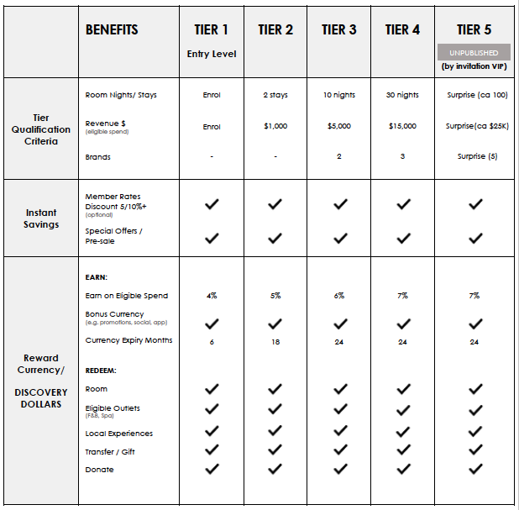

Notes:
- DISCOVERY member will only earn reward currency and be credited for tier qualification in respect of the first 30 nights of an extended stay
- Early check-in, late check-out and guaranteed rooms are all subject to availability.
- No earning on the part of folio settled with DISCOVERY Rewards Currency.
- Redemptions only against amounts on folio/invoice (therefore no redemption at check-out against pre-paid amounts)

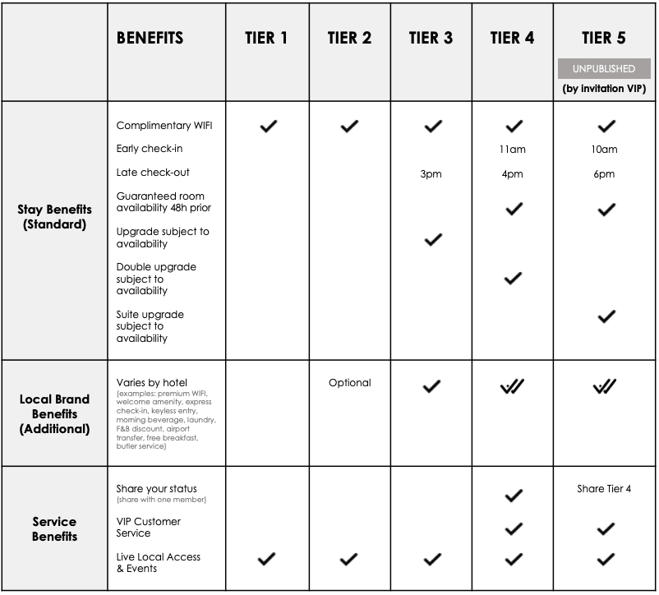

STATEMENT OF SERVICES SCHEDULE B
OTHER MEMBERSHIP SERVICES

GHA  SERVICE OFFERED | EXPLANATION | COST ALLOCATION | REQUIREMENT
Member  Hotel Champions | - Each Member Hotel or local/ regional cluster of hotels must nominate a DISCOVERY Hotel Champion, who will be responsible for all aspects of DISCOVERY management and training within their hotel. | Hotel Cost | Mandatory
Face-to-face Training | - All Member DISCOVERY Hotel Champions and Member DISCOVERY Brand Champions will undergo two days of a face-to-face or virtual “train the trainer” programme  - Member DISCOVERY Hotel Champions are responsible for ensuring all Member Hotel staff in their specific hotel, cluster or region are trained, as per the requirements of the training programme  - Travel and accommodation costs related to the training are to be borne by the Hotel | Hotel Cost | Mandatory
GM Training | - The GM of each Member Hotel (or the GM of each hotel cluster, in the case of hotels without dedicated GMs) must participate in a half-day introductory training programme. Costs related to this day’s training (time, travel etc.) are borne by the Member | Hotel Cost | Mandatory
E-learning | - An e-learning platform for DISCOVERY training will be made available and all Member employees will be expected to take regular refresher courses. An internal monitoring system is in place. | GHA | Mandatory
G-Leads | Sending Agent Incentive  G-Leads Champion Incentive  G-Leads third party system fee  GHA admin fee | Hotel Cost | Optional

STATEMENT OF SERVICES SCHEDULE C
Reimbursements of options for redemptions

- Flat Reimbursement Basis
Hotel is reimbursed 50% of the face value of the redeemed DISCOVERY Reward Currency in each redemption transaction.

- Stepped Reimbursement Basis
Hotel is reimbursed a variable percentage of the face value of the redeemed DISCOVERY Reward Currency, according to the total amount of DISCOVERY Reward Currency redeemed in the redemption transaction, as shown below:

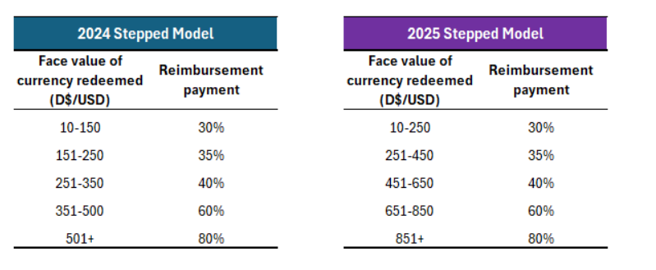

- Exceptional Demand Nights
If the chosen Reimbursement Basis for a year is the Flat Reimbursement Basis, then Member in agreement with the Hotel, may nominate up to ten nights per year in each Participating Hotel to be “Exceptional Demand Nights” with nominations being made on a hotel-by-hotel basis. Where a redemption of DISCOVERY Rewards Currency occurs during a stay at a Participating Hotel that includes at least one Exceptional Demand Night over the stay period, then the Stepped Reimbursement Basis will automatically apply to reimbursements for all redemptions in that stay.

